**Nginx as a web server and reverse proxy for Apache on Ubuntu and changing the default Apache root path.**

Login to the server run the below cmd

1. sudo apt update

Port change config file

sudo vi /etc/apache2/ports.conf

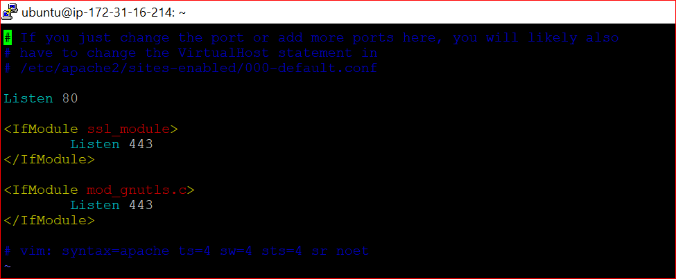

Once changed the port 80 to 8080.

Save Press esc :wq! And hit enter then restart the apache service.

**sudo systemctl restart apache2**

**sudo systemctl status apache2**

Apache status check

Nginx installation

apt install nginx

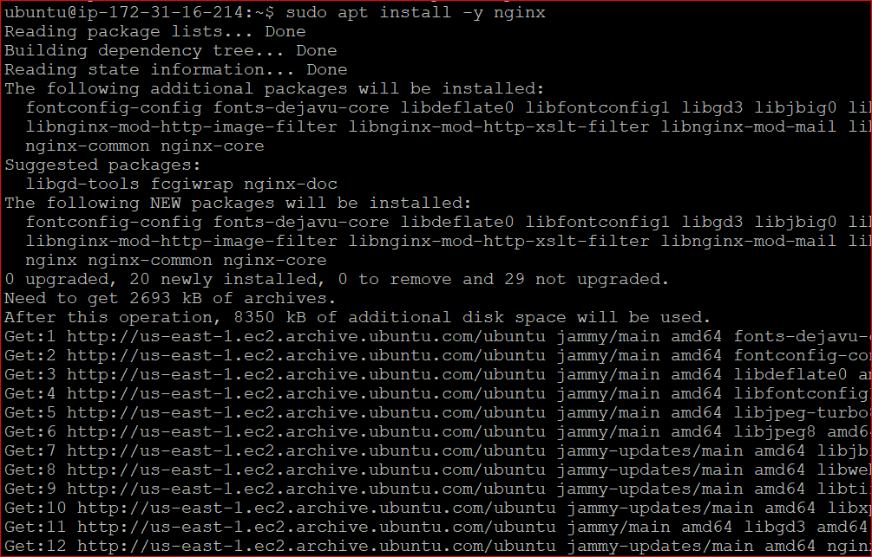

**sudo systemctl status nginx**

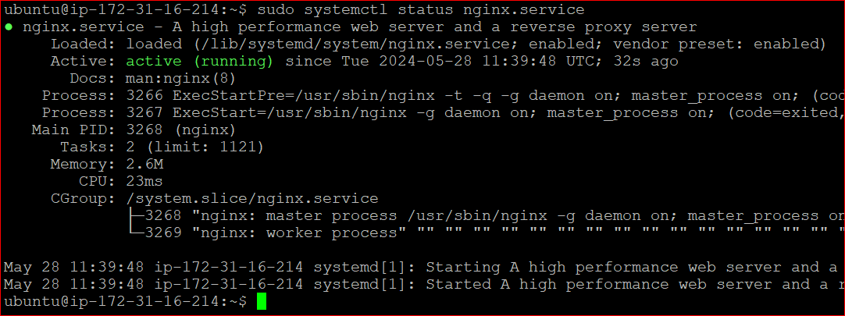

**Change the apache default root path directory.**

Go to cd /etc/apache2/sites-available

Open sudo vi 000-default.conf

Default Document root path /var/www/html/ changed to /home/ubuntu/myproject

Vi /etc/apache2/apache2.conf

<Directory /var/www/>

Options Indexes FollowSymLinks

AllowOverride None

Require all granted

</Directory>

Changed to as below

<Directory /home/ubuntu/myproject>

Options Indexes FollowSymLinks

AllowOverride None

Require all granted

Allow from all

</Directory>

Once changed the path we should restart the apache service.

Sudo systemctl restart apache2

**Virtual host creation for apache and change document root and directory.**

Go to cd /etc/apache2/site-available/

Sudo vi virtualhost.conf

<VirtualHost *:8080>

DocumentRoot /home/ubuntu/myproject/

<Directory /home/ubuntu/myproject>

Options Indexes FollowSymLinks

AllowOverride All

</Directory>

</VirtualHost>

Press esc :wq! Then press enter and create a symbolic link

ln -s /etc/apache2/sites-available/virtualhost.conf /etc/apache2/sites-enabled/

Sudo systemctl restart apache2

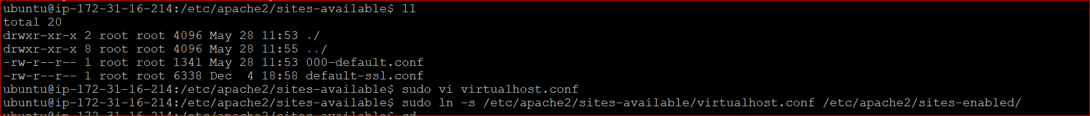

Go to cd /etc/nginx/site-available/

Create a file sudo vi ssl.conf

server {

listen 80;

server_name 54.198.76.201;

root /home/ubuntu/myproject;

index index.html index.htm;

location / {

proxy_pass http://127.0.0.1:8080; # This points to Apache running on port 8080

proxy_set_header Host $host;

proxy_set_header X-Real-IP $remote_addr;

proxy_set_header X-Forwarded-For $proxy_add_x_forwarded_for;

proxy_set_header X-Forwarded-Proto $scheme;

}

}

Press esc :wq! Then press enter and create a symbolic link.

sudo ln -s /etc/nginx/sites-available/ssl.conf /etc/nginx/sites-enabled/

sudo nginx -t

sudo systemctl restart nginx

Note : server name we should mention domain name but I mentioned the public Ip



* After configuring the reverse proxy, we need to push the code into a directory using either the ci/cd Jenkins pipeline or SFTP.
* We upload the files directly to the directory and then try to access the site using a public IP or domain name.
* When you access the site, you may encounter a prohibited permission issue. please run the below command

Sudo **chmod 755 /home/ubuntu**

The Apache service has stopped due to memory or CPU issues, resulting in the site not working, but the nginx default page will appear as shown in the screenshot below.

